**EX NO :3b DATE:8.03.2025**

**NAME:S.Subramanian**

**ROLL NO:230701349**

**Create a prototype with familiar and unfamiliar navigation elements. Evaluate ease of use with different user groups using wireflow**

**AIM:**

The aim is to design a prototype with both well-known and new navigation elements and measure user-friendliness across different user groups using Wireflow.

**PROCEDURE:**

**Tool link:** [**https://wireflow.co/**](https://wireflow.co/)

**Step 1: Plan Your Prototype**

1. Define Navigation Elements:
   * *Familiar*: Standard menus, top bars, footers, and sidebar navigation.
   * *Unfamiliar*: Novel features such as hidden menus, gesture-based navigation, or custom swipes.
2. Sketch Your Layout:
   * Start with paper sketches or use tools like Figma or Sketch to visualize your design concepts.

**Step 2: Set Up Your Wireflow Project**

1. Sign Up/Log In:
   * Head to Wireflow and create an account or log in if you already have one.
2. Start a New Project:
   * Click on "New Project" and name it. Choose a template or start from scratch.

**Step 3: Design the Prototype**

1. Add Familiar Navigation Elements:
   * Drag and drop components like menus, header bars, buttons, etc., into your screens.
2. Incorporate Unfamiliar Elements:
   * Introduce hidden menus, unique gestures, or unexpected interactions.
3. Link Screens:
   * Use Wireflow's linking tools to create connections and transitions between screens.

**Step 4: Prepare for Usability Testing**

1. Identify User Groups:
   * Segment users based on age, tech-savviness, or previous experience with similar products.
2. Recruit Participants:
   * Use online tools like UserTesting, forums, or social media to find participants.

**Step 5: Conduct Testing**

1. Share the Prototype:
   * Invite users to interact with your prototype via a shareable link from Wireflow.
2. Test Sessions:
   * Ask users to complete tasks using both types of navigation. Observe their interactions and collect feedback.
3. Collect Feedback:
   * Utilize Wireflow's feedback features or conduct follow-up interviews to gather detailed responses.

**Step 6: Analyze and Report**

1. Analyze Data:
   * Review the feedback and data collected. Look for patterns in ease of use and user preferences.
2. Compare Results:
   * Compare how different user groups interacted with familiar vs. unfamiliar navigation.
3. Create a Report:
   * Summarize your findings, highlighting insights, challenges, and recommendations

**OUTPUT:**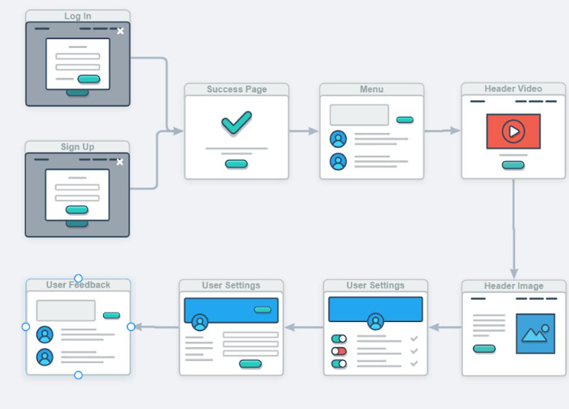

**RESULT:**Hence , creating a prototype flowchart for online shopping system using wireflow has been executed successfully.